26th Mar 2025

Fixing the opposite end of the membrane and testing seal of the chamber system

Overview:
- A flexible membrane will be used to connect the 3D-printed parts of the bioreactor chamber
- The flexibility of the membrane ensures sufficient transmission of mechanical signals from the mechanical system
- Establishing a leak-proof connection between the 3D-printed parts and the membrane is essential

- In this experiment, the full chamber will be assembled with 3D printed parts on both sides connected by the flexible membrane
- The assembled chamber will then be analyzed for potential leakage by running water through the system

- The following setup is used to seal the 3D printed parts and membrane together
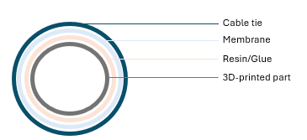
- An adhesive glue will be applied between the 3D-printed part and the membrane
- A cable tie will be used to cover the contact point between the 3D-printed part and the membrane to further tighten the seal

- Chamber: 3D-printed clear medical grade resin
- Adhesive: Polyurethane glue
- Flexible membrane: Permali Tuftane Thermoplastic Polyurethane film

Procedure:
Assembly
- Produce a flexible membrane sleeve with a diameter of 3.8cm
- Place the flexible membrane onto the 3D printed part
- Use a syringe and needle to add the adhesive glue between the printed part and the membrane
- Place a cable tie on top of the contact area of the membrane and printed part and tighten it
- Leave the glue to dry for 12 hours

Leak test
- All luer locks except one will be closed/sealed
- A large syringe will be filled with water and attached to the system
- The water will be run through the system creating pressure to identify potential points of leakage

Results:
Final chamber:
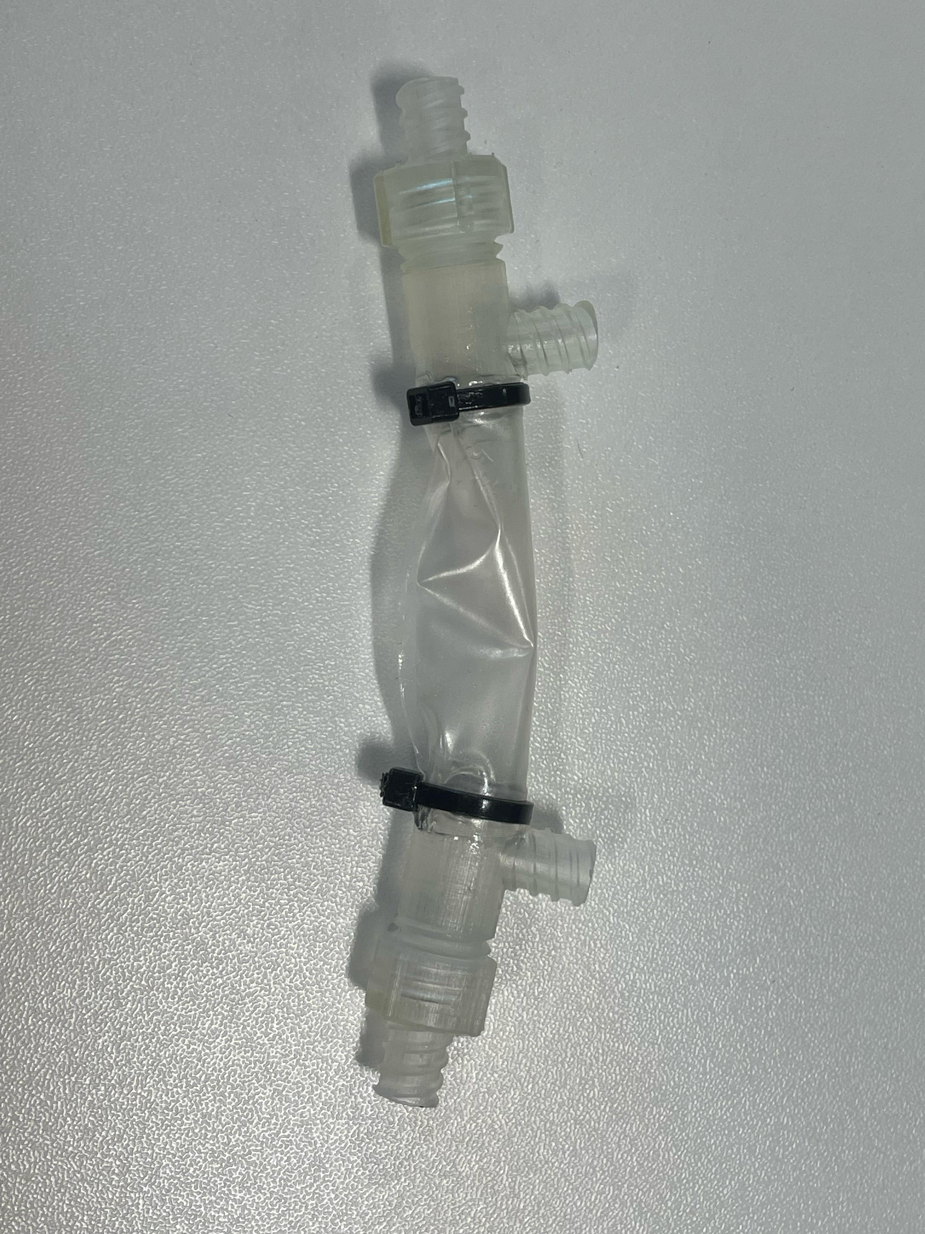
- Luer stops were used effectively for the ends, however, the side outlets/inlets could not be closed
- This could be due to residues of support structures from the printing process
- Blue tac was used as a temporary solution to seal the side outlets/inlets

Leak test setup:
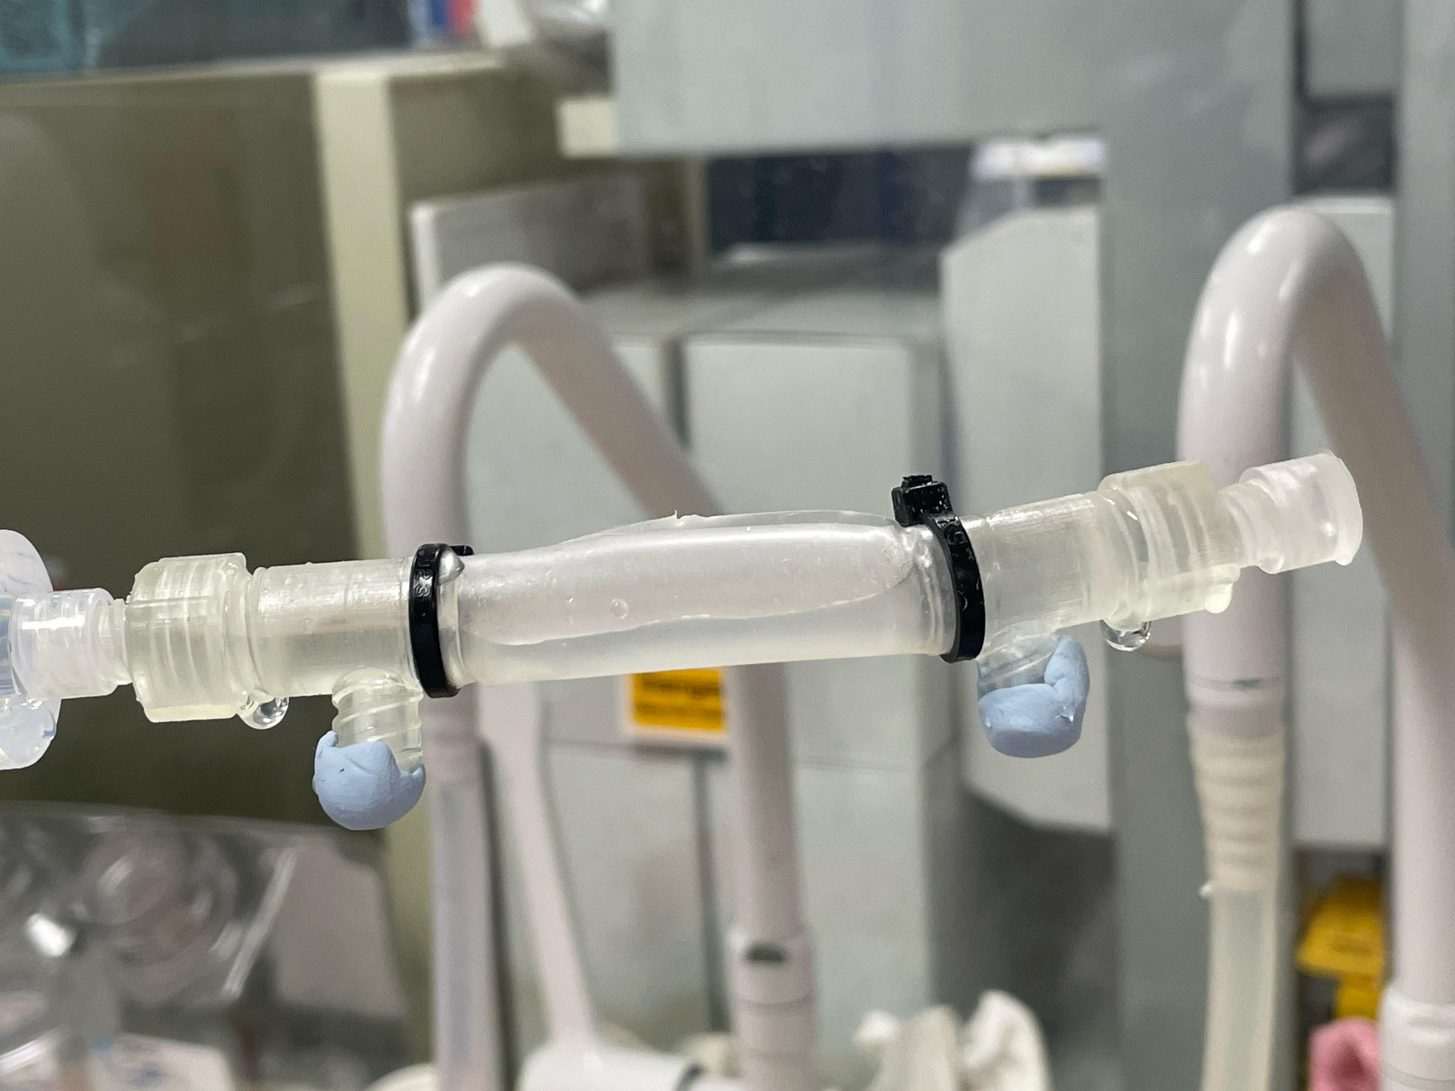
- Leakage was observed at the screwed parts on both sides
- Parafilm and tape were tested to seal the screwed parts
- The tape showed not to reduce leakage
- Parafilm showed to cause a reduction in leakage, however, some small drop formation was still observed
- Subsequently, parafilm in combination with vacuum grease was tested. This showed to seal the screwed parts with no observed leakage

Next steps:
- Test elastic rings instead of cable ties for assembly of the chamber
- Remove blockage inside side outlets/inlets and test the luer stop again
- Run leak test with luer stops on the side outlets/inlets
- Test polyurethane glue (instead of parafilm) to seal the screwed ends

